Develop the web application using Node-Red

|  |  |
| --- | --- |
| **Team ID** | **PNT2022TMID50805** |
| **Project Name** | **Hazardous Area Monitoring for Industrial Plant powered by IOT** |

Configure the Node-RED flow to receive data from the IBM IOT platform:

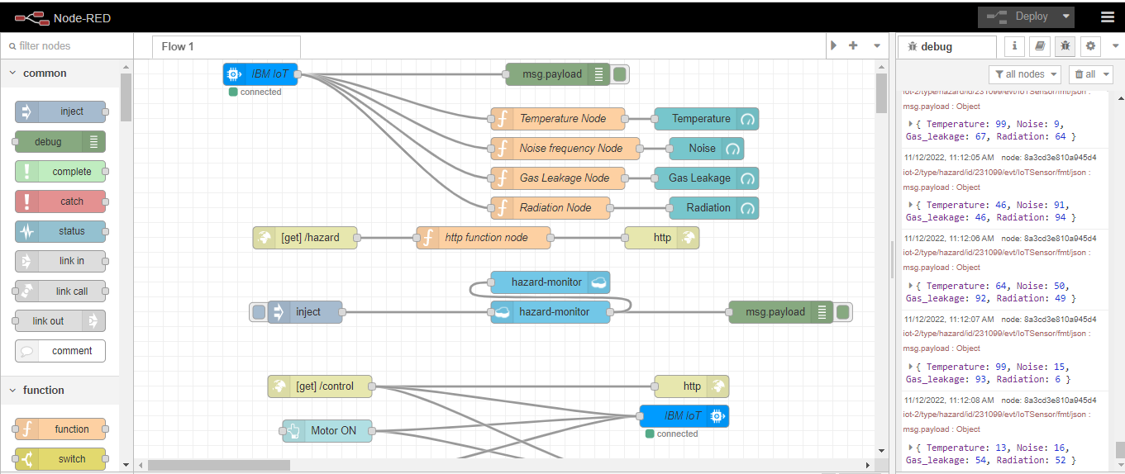

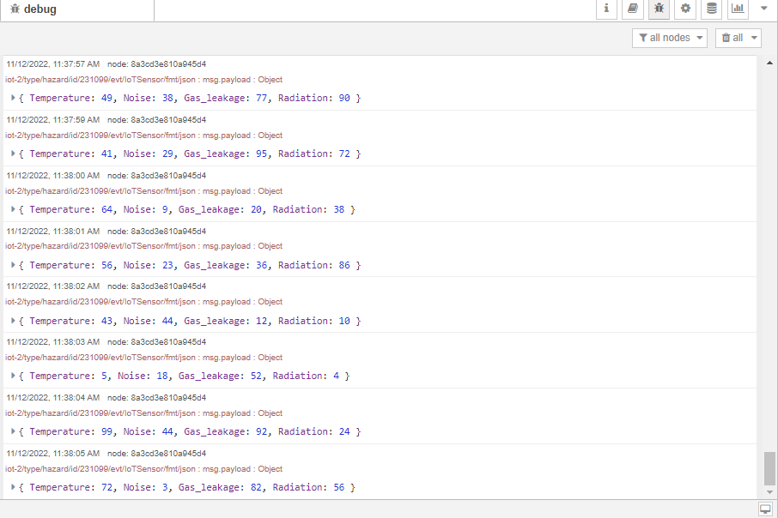

Usage of cloudant node to receive data from cloudant db:

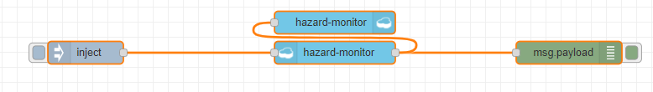

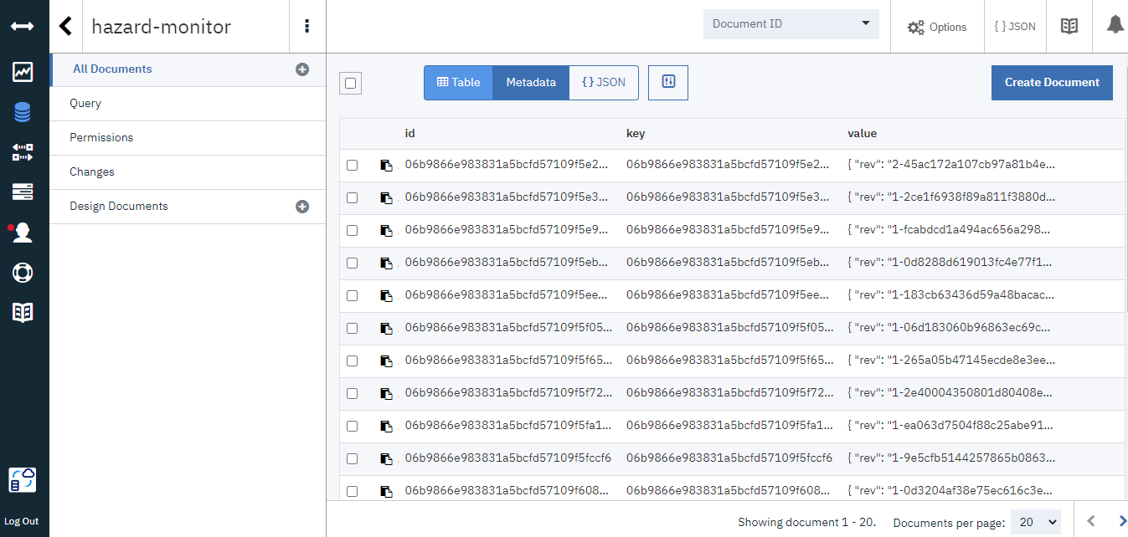

Data received:

